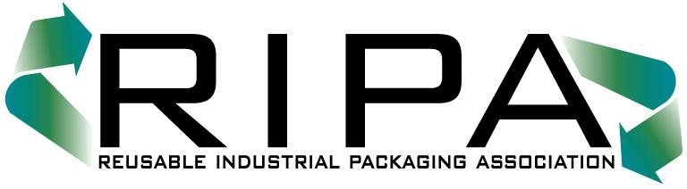
51 Monroe Street
Suite 812
Rockville, Maryland 20850
TEL (301) 577-3786 / FAX (301) 577-6476
www.reusablepackaging.org

RIPA CERTIFIED PUBLIC ACCOUNTANT’S CERTIFICATION
(RECONDITIONERS & BROKERS)

I certify this document accurately represents for the company listed below the gross receipts reported on Line 1a of the U. S. Corporate Income Tax Return (IRS Form 1120) or other appropriate income tax return for the last completed fiscal year prior to December 1, 2019.

PLEASE DESIGNATE THE APPLICABLE REVENUE CATEGORY:

Sales Category | Check Category ✓ | Annual Payment | Quarterly Payment  10% Surcharge
$0 mil. – 4 mil. |  | $5,200¹ | $1,430.00
$4 mil. - 6 mil. |  | $9,500 | $2,612.50
$6 mil. - 8 mil. |  | $12,200 | $3,355.00
$8 mil. - 10 mil. |  | $15,000 | $4,125.00
$10 mil. - 15 mil. |  | $20,000 | $5,500.00
$15 mil. - 20 mil. |  | $27,000 | $7,425.00
$20 mil. - 30 mil. |  | $34,000 | $9,350.00
$30 mil. - 75 mil. |  | $50,000 | $13,750.00
$75 mil. - 150 mil. |  | $70,000 | $19,250.00
$150 mil. - 250 mil. |  | $90,000 | $24,750.00
$250 mil. + |  | $130,000 | $35,750.00

¹ Important: Companies who were members of the association in the previous year and who can demonstrate that their annual gross revenues are less than $2 million, qualify for a dues reduction of $700, i.e. $4,500. Companies seeking this dues exception must provide to RIPA this Accountant’s Certification Form, signed by the company accountant. The certification must accompany the invoice and annual or quarterly dues payment to RIPA.

Accounting Firm’s Name |  | Accountant’s Signature
Address |  | Name/Print or Type
(City, State, Zip Code) |  | Date

Member’s Company Name: _______

