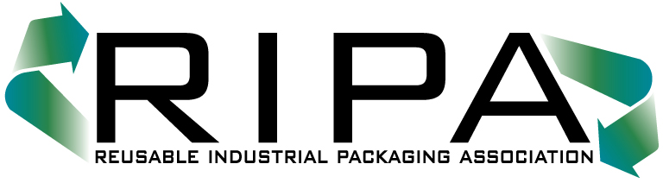150 South Street

Suite 103-B

Annapolis, Maryland 21401

TEL (301) 577-3786/FAX (301) 577-6476

www.reusablepackaging.org

_____________________________________________________________________________________

**SPECIAL BULLETIN 2025 – 01**

**January 23, 2025**

President Issues Executive Order Halting Issuance of

New Regulations

*U.S. EPA “Used Drum” Inquiry on Hold*

President Trump has issued an Executive Order, *“Regulatory Freeze Pending Review”*,

directing all executive departments and agencies to immediately freeze all rulemakings “…until a department or agency head appointed or designated by the President…reviews and approves the rule.”  The only exception to this Order is if the Office of Management and Budget exempts a rule that he deems necessary to address emergency situations or other “urgent circumstances.”

For the reconditioning industry, this Order means that the Environmental Protection Agency may take no further steps to move forward on its Notice of Proposed Rulemaking on *“Used Drum Management and Reconditioning, Advance Notice of Proposed Rulemaking,”* ***or*** obtain container management data from reconditioners via an Information Collection Survey.

This rulemaking moratorium has no expiration date, so it appears that while various rules are under review by OMB, no action on them is permitted.

Given the volume of rulemaking activity throughout the federal government, it is unlikely that the “used drum” NPRM will be on hold for many months, if not years.