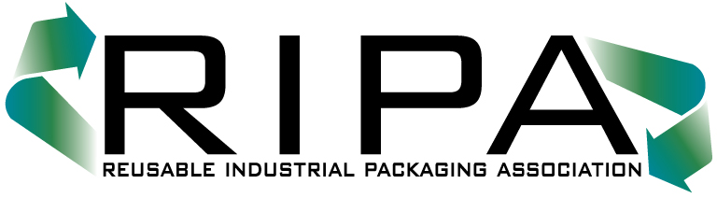150 South Street

Suite 103-B

Annapolis, Maryland 21401

TEL (301) 577-3786/FAX (301) 577-6476

www.reusablepackaging.org

_____________________________________________________________________________________

**SPECIAL BULLETIN 2021 - 14**

May 26, 2021

**RIPA Offers Searchable Mobile Membership Directory**

RIPA has created a simple, searchable list of association members that can be stored on your computer or uploaded to the cloud for easy access at any time. The virtual Membership Directory includes all member listings, including company name, member contacts, phone, fax and email listings. What could be easier?

All you must do is save the .pdf document to the location of your choice. When you open the link, the directory will open to the cover page. Click the search icon  (usually at upper left) and a search bar will open on your screen. Type in the name of the company or person you wish to locate and hit enter.

All the listings of that company or person will come up. If the company or individual is listed in various places in the directory, simply scroll up (˄) or down (˅) to find the next appearance of the name or company highlighted in yellow.

User Tip: If ABC Barrel Co. has more than one location – and you are just looking for a particular location – it will be most efficient to just type in the location (e.g., Atlanta) and hit enter.

Click **here** for the searchable .pdf version of your directory.

We hope you enjoy your electronic membership directory.