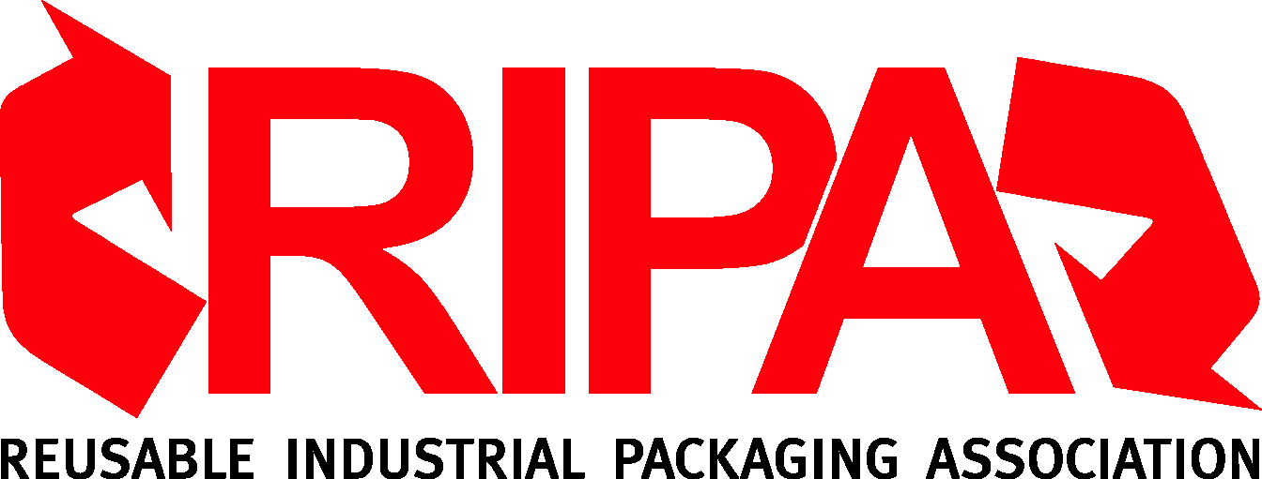
8401 Corporate Drive
Suite 450
Landover, MD 20785-2224
TEL (301) 577-3786 / FAX (301) 577-6476
www.reusablepackaging.org

SIC, NAICS Industry Codes & Small Business Thresholds
June, 2012

Businesses are often asked whether they qualify as a “small business” according to the U.S Small Business Administration. Often, too, they are asked to identify themselves by the code for the industrial category in which they generate the most revenue. Presented here are the industry classification codes and small business thresholds for RIPA’s members. (While some governmental agencies have adopted the use of the 1997 NAICS industry classification codes, others may still rely on the 1987 SIC codes.)

For industrial packaging reconditioners:

SIC 7699 Repair Shops and Related Services, Not Elsewhere Classified. (NEC)
NAICS 811310 Commercial and Industrial Machinery and Equipment (except Automotive
and Electronic) Repair and Maintenance

“Small Business” Threshold: Up to $7 million in revenue

For steel drum manufacturers:

SIC 3412 Metal Shipping Barrels, Drums, Kegs and Pails
NAICS 332439 Other Metal Container Manufacturing

“Small Business” Threshold: Up to 500 employees

For plastic packaging manufacturers:

SIC 3085 Plastic Bottles
NAICS 326160 Plastics Bottle Manufacturing

SIC 3089 Plastic Products, Not Elsewhere Classified
NAICS 326199 All Other Plastics Product Manufacturing

“Small Business” Thresholds: Up to 500 employees

For industrial packaging distributors:

SIC 5085 Industrial Supplies
NAICS 423840 Industrial Supplies Wholesalers (Drums, new and reconditioned,
wholesaling; Containers, industrial, wholesaling)

“Small Business” Thresholds: Up to 100 employees

